SUCCESS SECRETS WITH ALEX

MAKE MONEY WITH AI CHALLENGE | தமிழ்

DAY 2 MINI-PROJECT | Your First Vibe Coding Experience
<NIRUPAMASHREE>

[STEP 1] YOUR IDEA (Based on The 10X Think Like a BUILDER Blueprint™):
A Smart Car Food Ordering System. Customers at a drive-in can order food from their car, without getting out or waiting in a long line. The app has a home page, an order page with a live total, an About Us page, a support page with a chatbot, and an admin page for managing orders and viewing the database.

[STEP 2] YOUR IDEA EXPANSION (From the Questionnaire):
✅ What PROBLEM(S) does your IDEA Solve?
- Drivers have to wait in long lines or get out of their cars to order food.
- Orders are often mixed up or written down by hand, so mistakes happen.
- Customers cannot easily check if their order is ready.
- Staff have no simple view of all orders, their status, or the day’s revenue.
- Customers with questions (menu, hours, cancellations) have no quick place to ask.
✅ What RESULT(S) can your IDEA Achieve?
- Customers order and pay for food from their car in a few clicks.
- Each order gets a number and a status (Pending, Preparing, Ready, Delivered, Cancelled).
- Customers can check their order status using the chatbot.
- Staff can update order status and search orders from one admin page.
- Managers can see order counts and revenue on the dashboard.
- Customer questions are answered at any time by the support chatbot.
✅ What VALUE(S) can your IDEA Generate?
- Faster service, so more cars are served in the same time.
- Fewer order mistakes, because each order is saved in the database.
- Better customer experience, with a modern look and clear order tracking.
- Useful sales data, such as popular items and daily revenue.
- Lower staff workload, because the chatbot answers common questions.
- A simple base that can grow later, such as real payments or photos of food.

[STEP 3] YOUR PROMPT (From the Questionnaire):
Hi Claude, assume you are a software engineer who works on project development by building code from scratch and satisfies the customer. Now your task is to build a complete Flask web app called “Smart Car Food Ordering System” for local development on Windows (Python 3.13, Flask 3.x, sqlite3 only, plain HTML/CSS/JavaScript).
Create these pages:
- Home (/): hero section, feature list, today’s menu preview, and a button to start ordering.
- Order page (/orderpage): stats, AI recommendation, menu picker, name and car number fields, quantity picker with live total, Place Order button, and a live queue of recent orders.
- About Us (/about): story, mission, how it works (3 steps), values, and an order button.
- Support (/support): FAQ and a live chatbot that answers about the menu, hours, order status by order number, and cancellations. A floating chat button appears on all pages except support.
- Admin (/admin): password-protected. Shows totals and revenue, filters by status, searches by customer or car number, changes order status, and deletes orders.
- Database view (/admin/db): shows row counts, table rows, and the schema for the orders and support_messages tables.
Rules:
- Use a menu list (Burger, Pizza, Coffee, Tea) with prices defined once in app.py.
- Save orders and chat messages in SQLite (smartcar.db, created automatically).
- Use the exact template and function names so every url_for link works.
- Check all form input on the server and use parameterised SQL queries.
- Admin login uses the ADMIN_USER and ADMIN_PASS environment variables (defaults admin / admin123).
- Deliver one zip file named CarFoodOrderingSystem.zip, the full code of every file in the chat, and a beginner-friendly START-TO-END setup guide for Windows with a troubleshooting table and a test list.
Note: The full build prompt with every route, template, and style detail is the one I gave you in my previous message. Paste that full version into your AI tool if you want the complete build instructions.

[STEP 4] YOUR CODE’s SCREENSHOTS: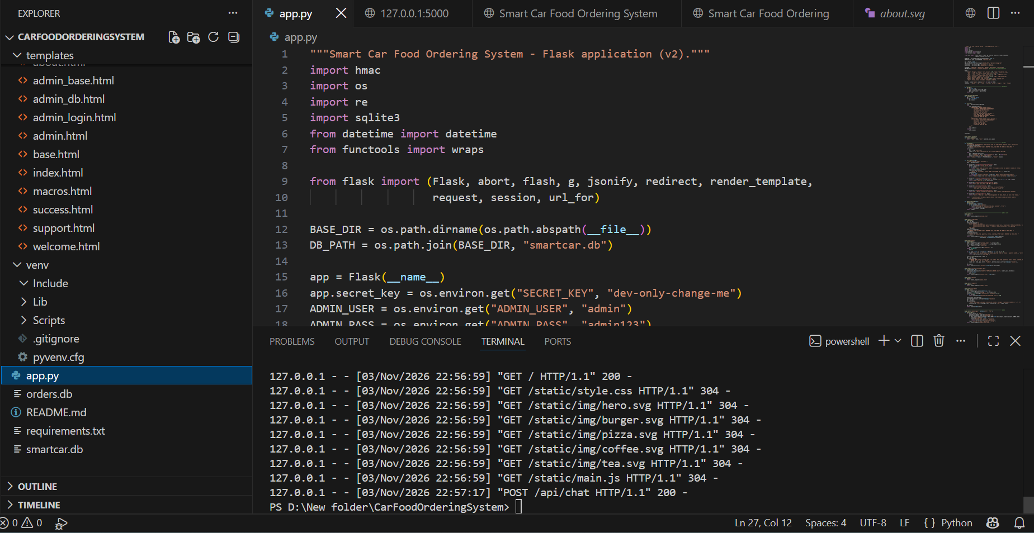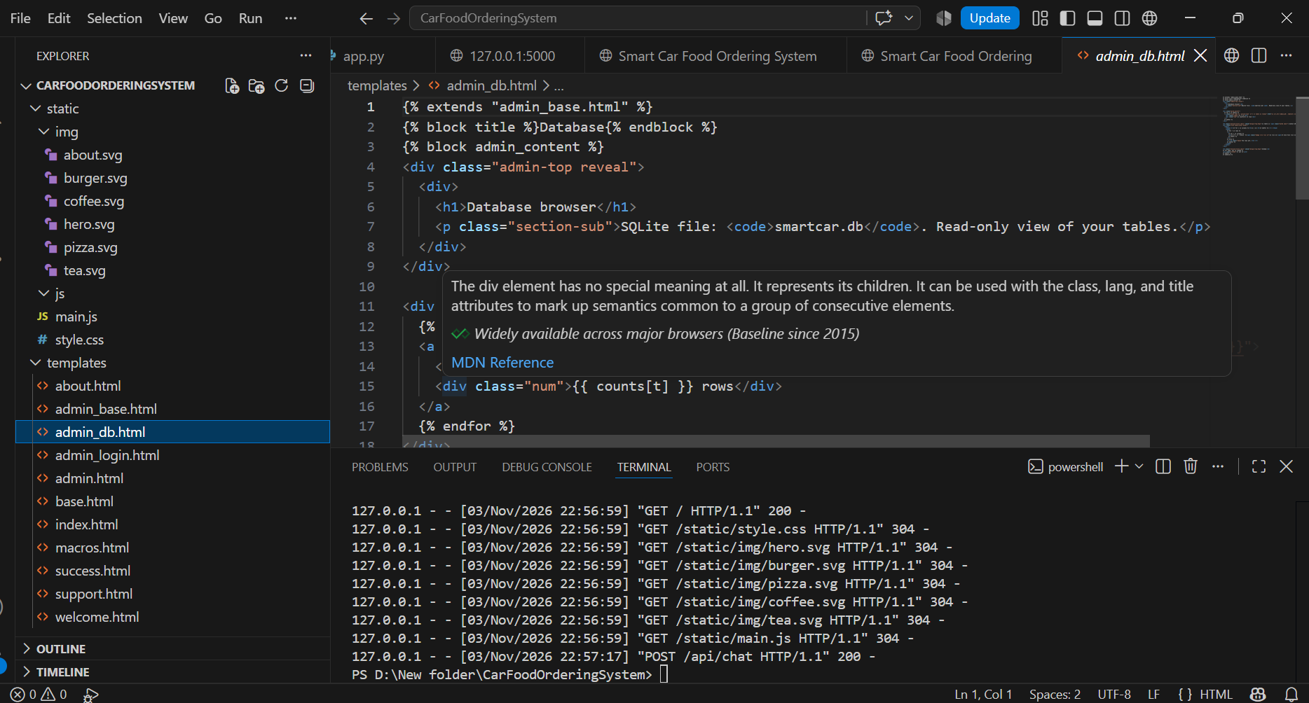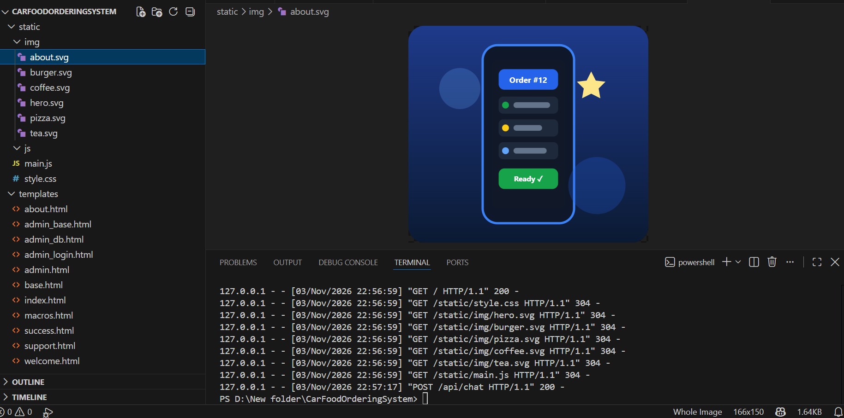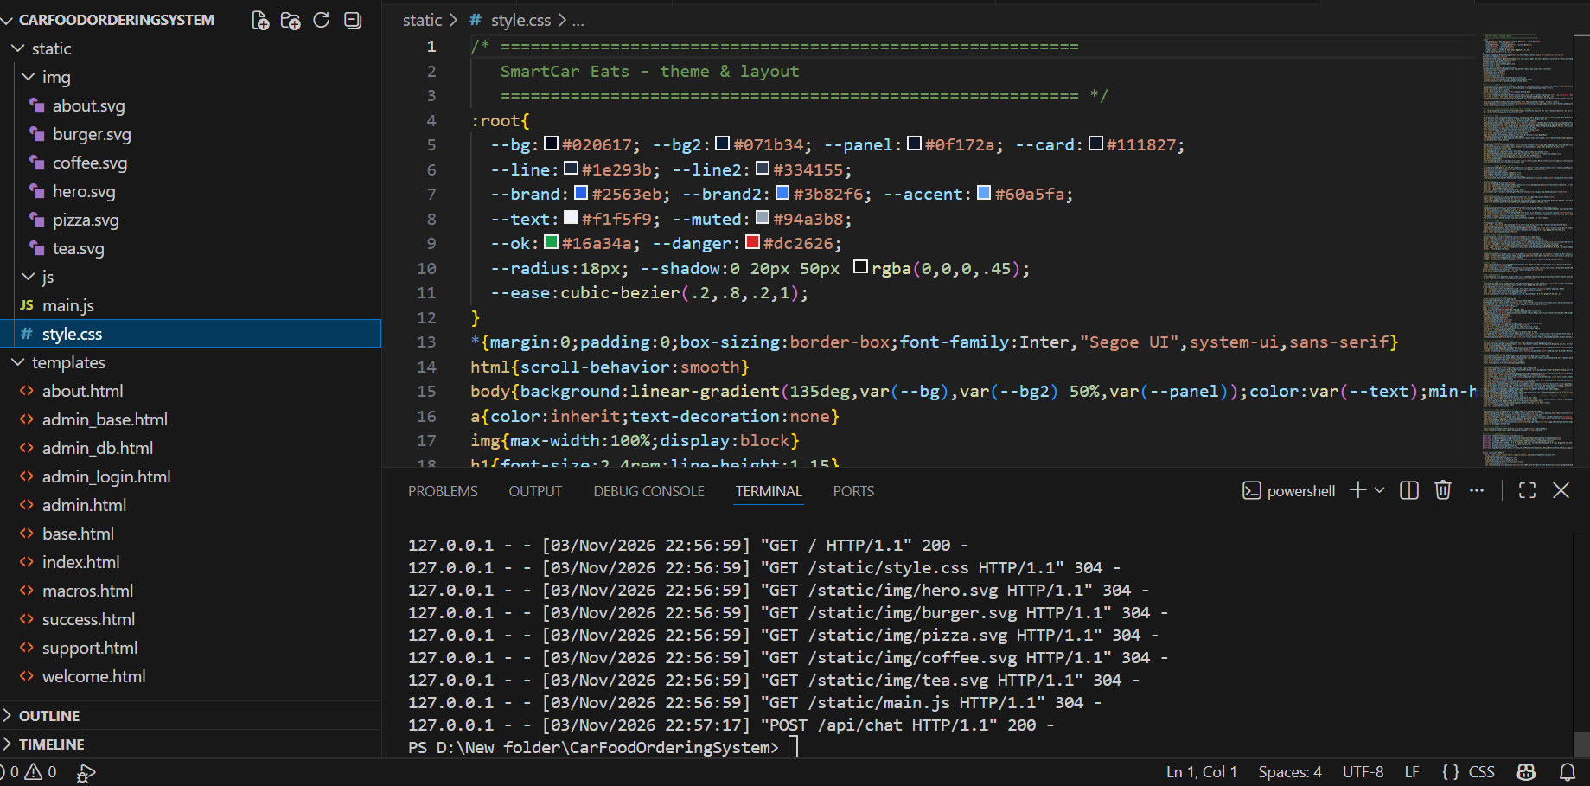

[STEP 5] YOUR CODE EXECUTION’s SCREENSHOTS:
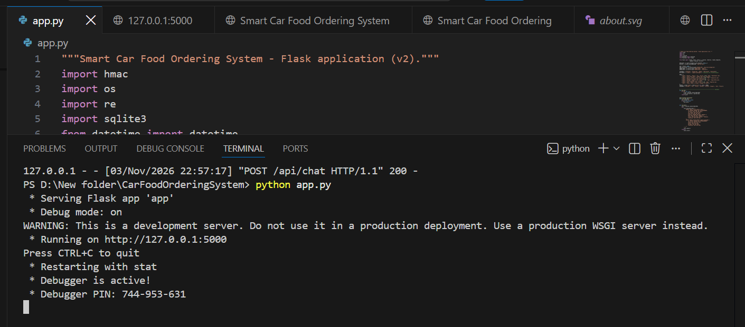
HOME PAGE
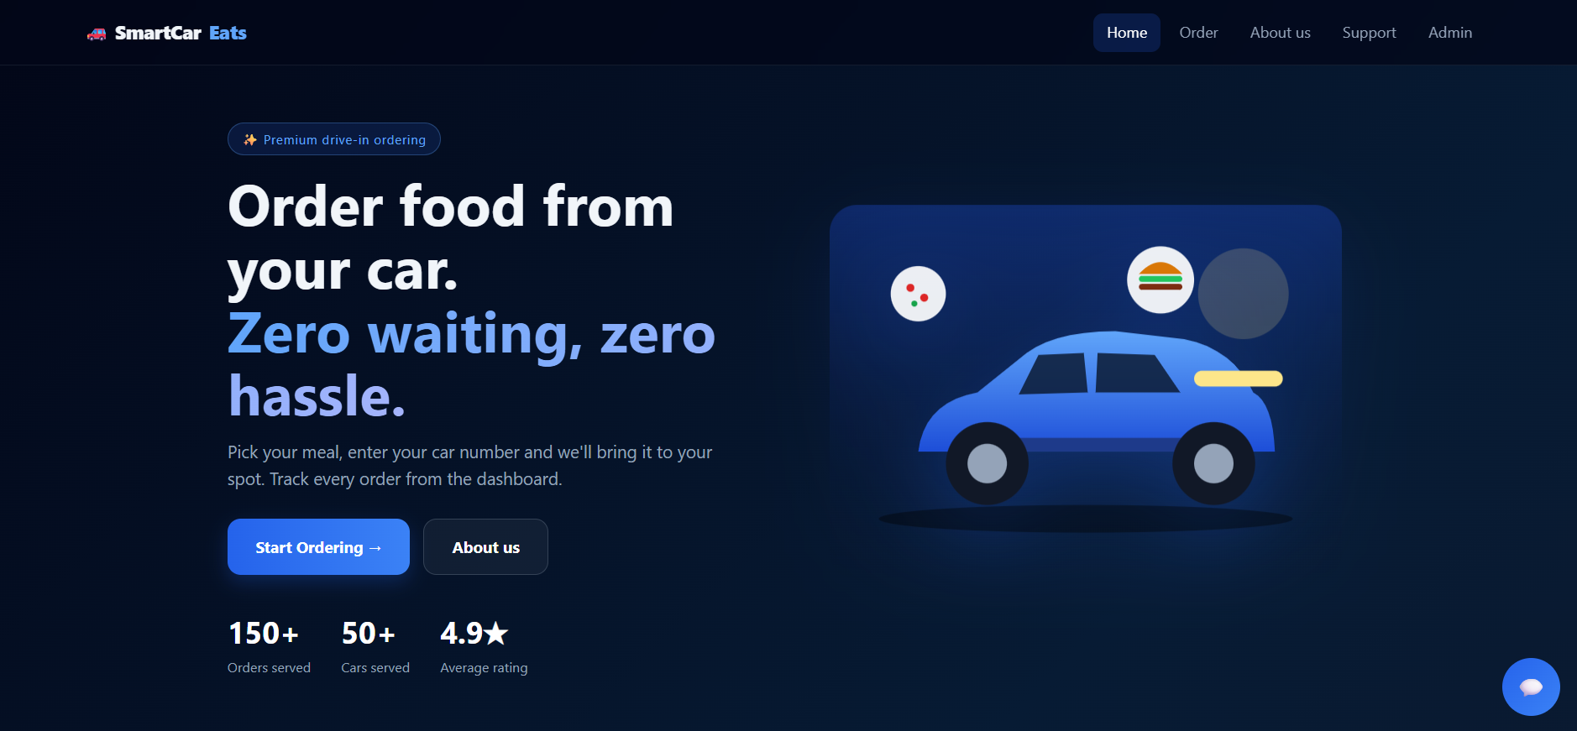
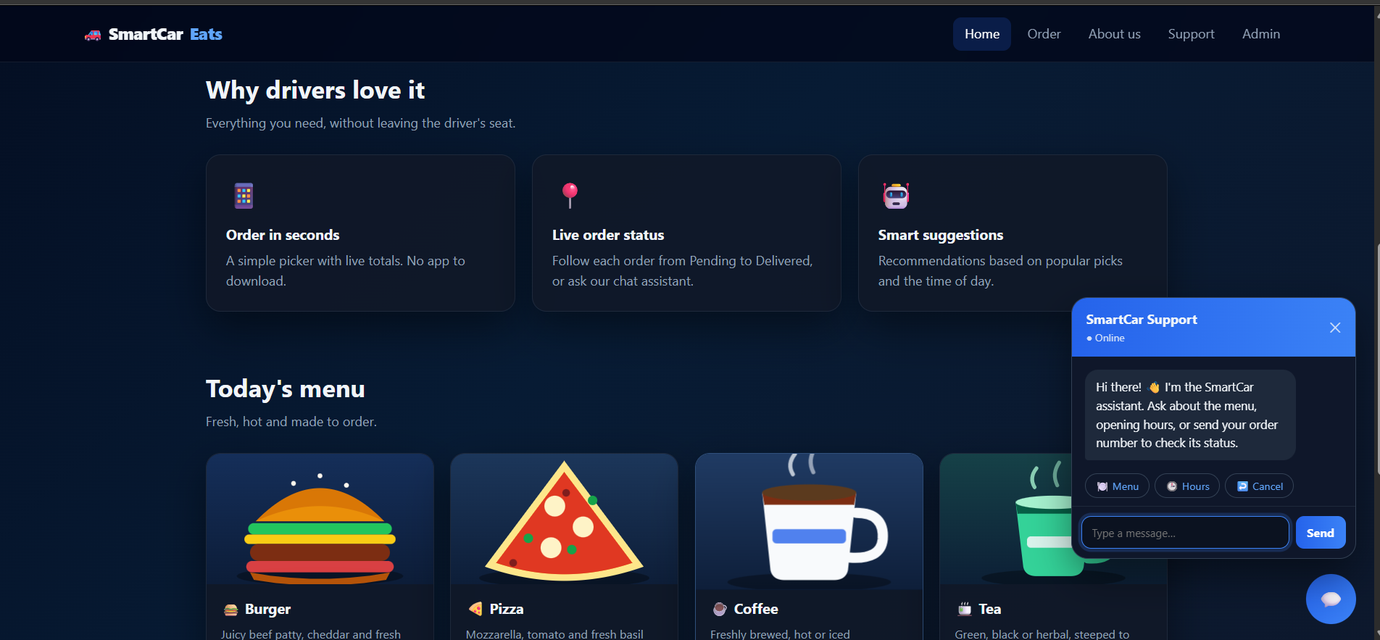
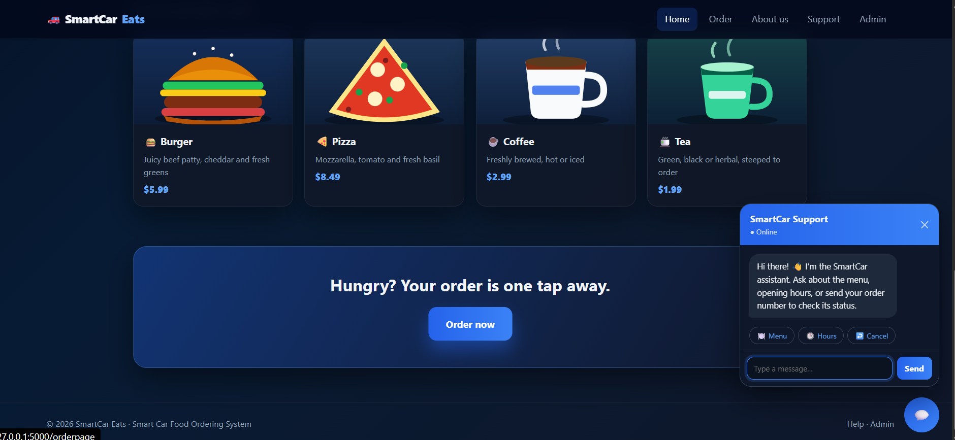
SUPPORT CHATBOT RESPONSE
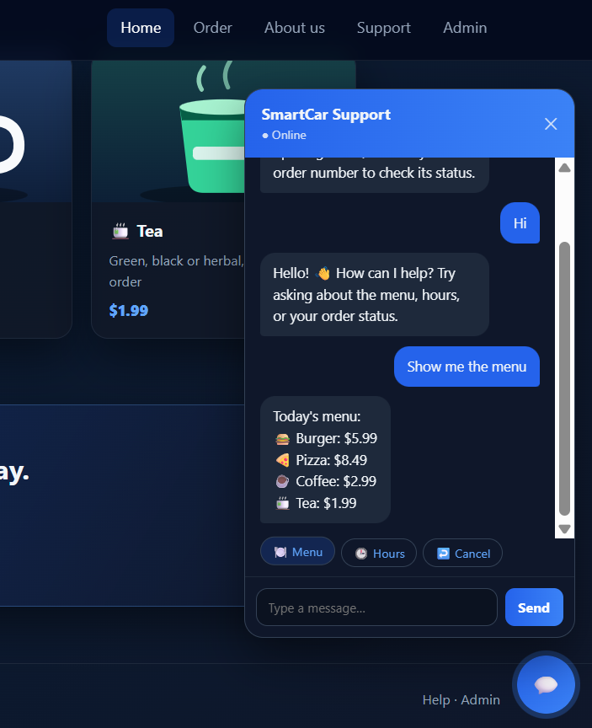
ORDER PAGE
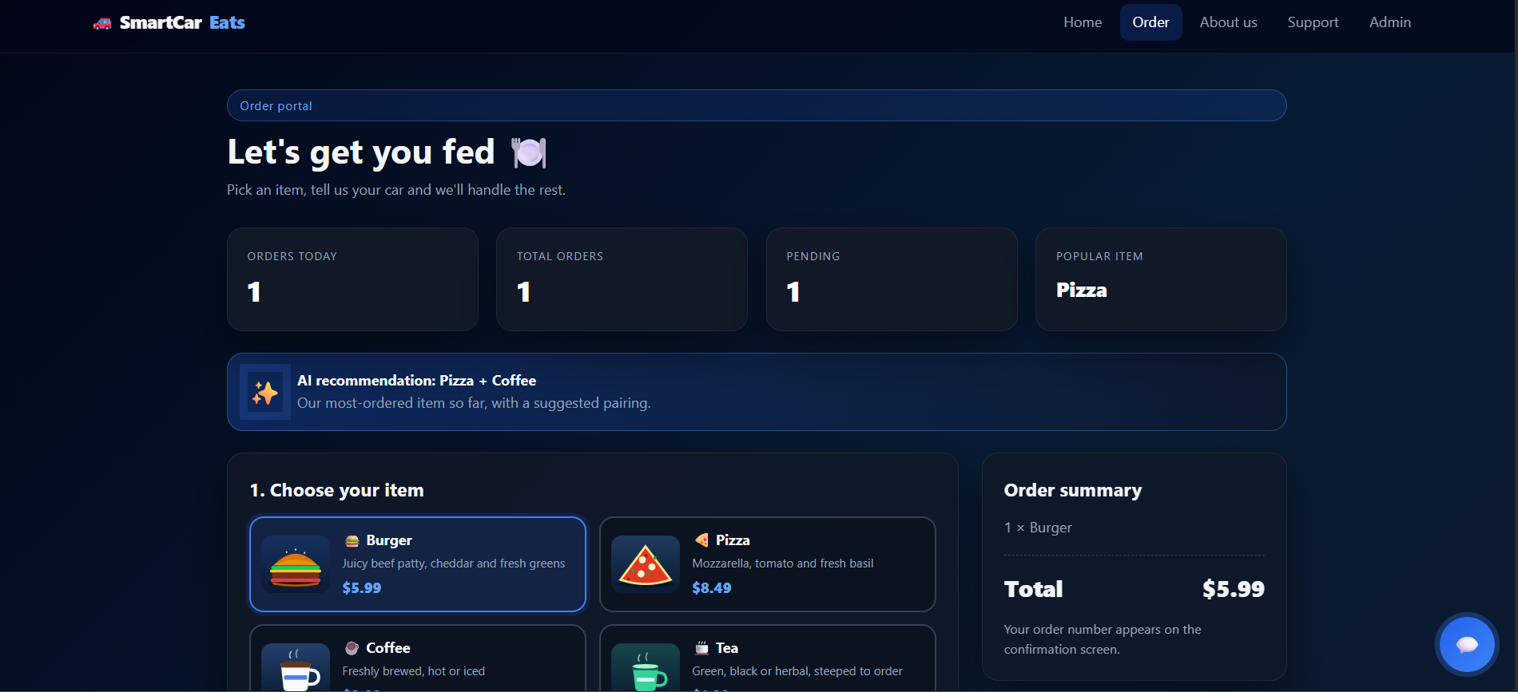
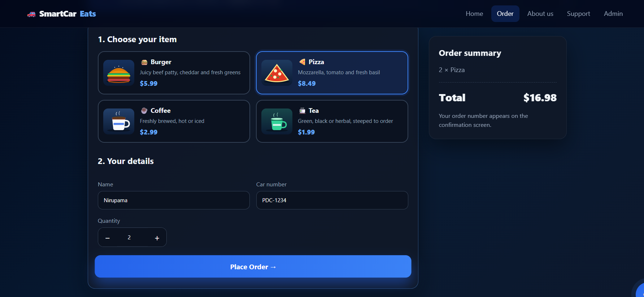
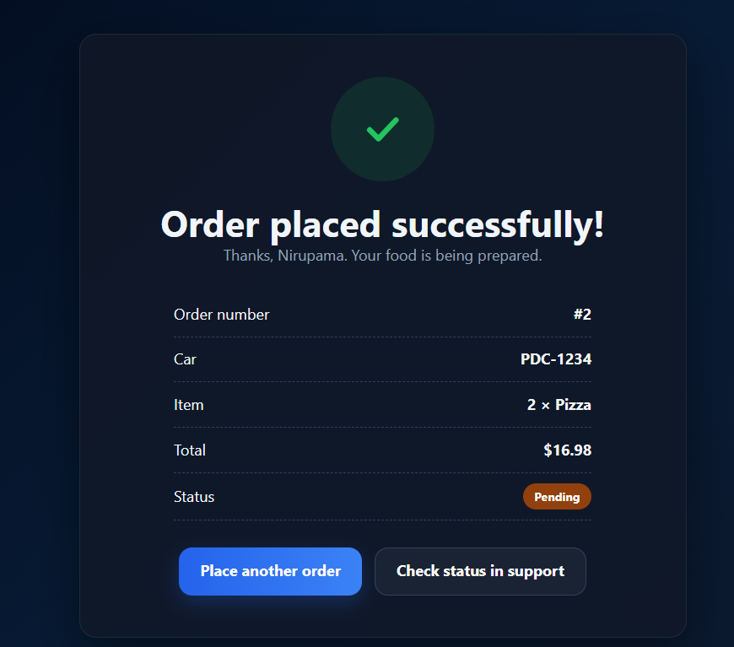
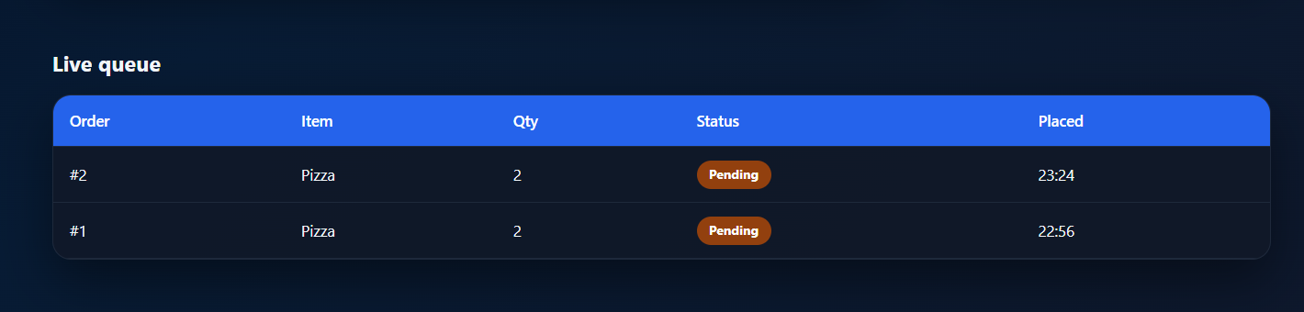

ABOUT PAGE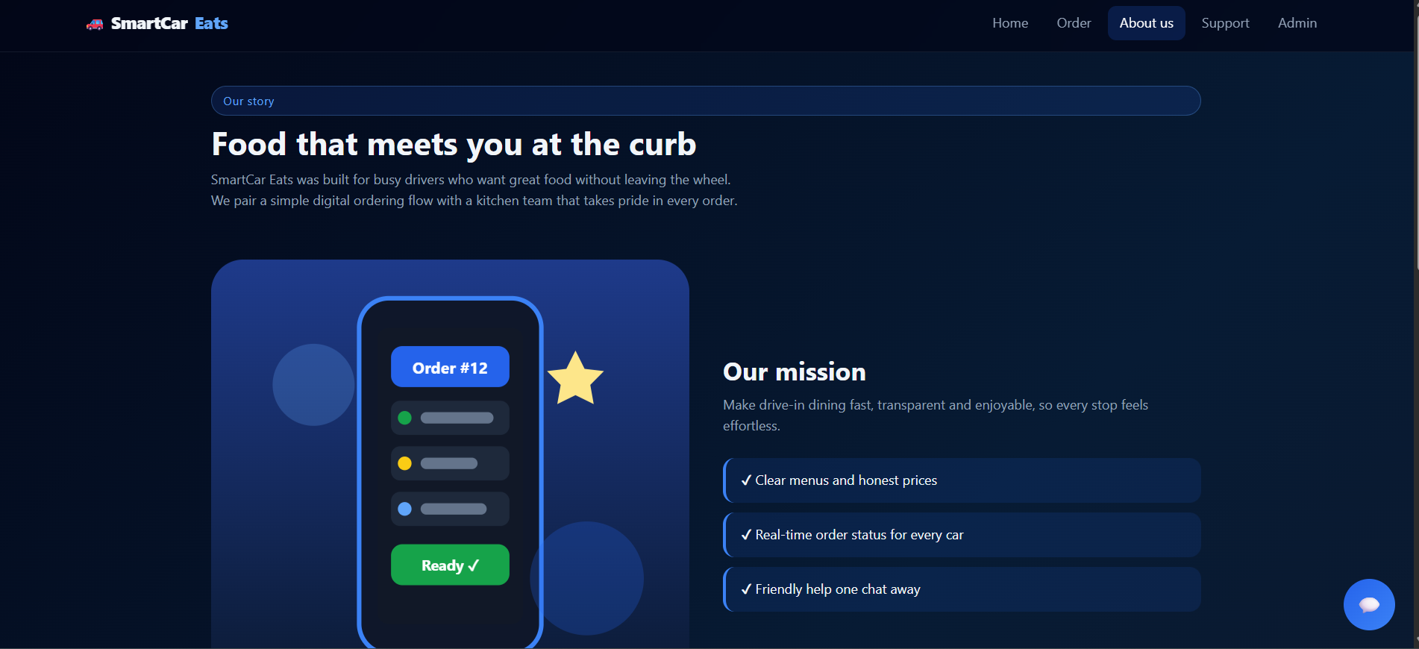

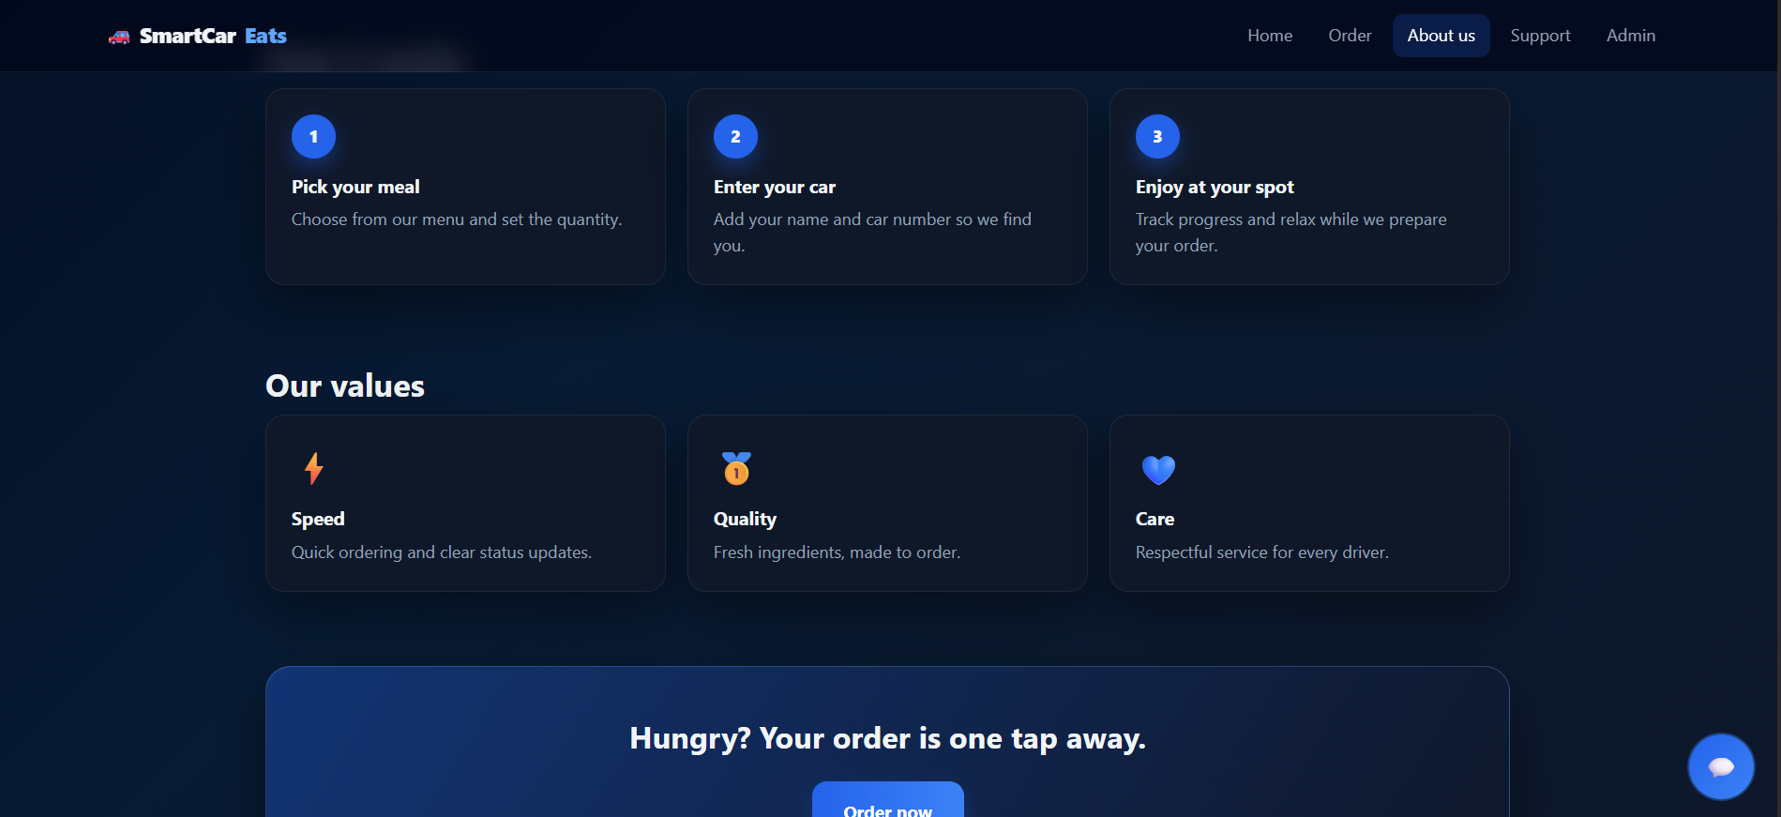

SUPPORT PAGE
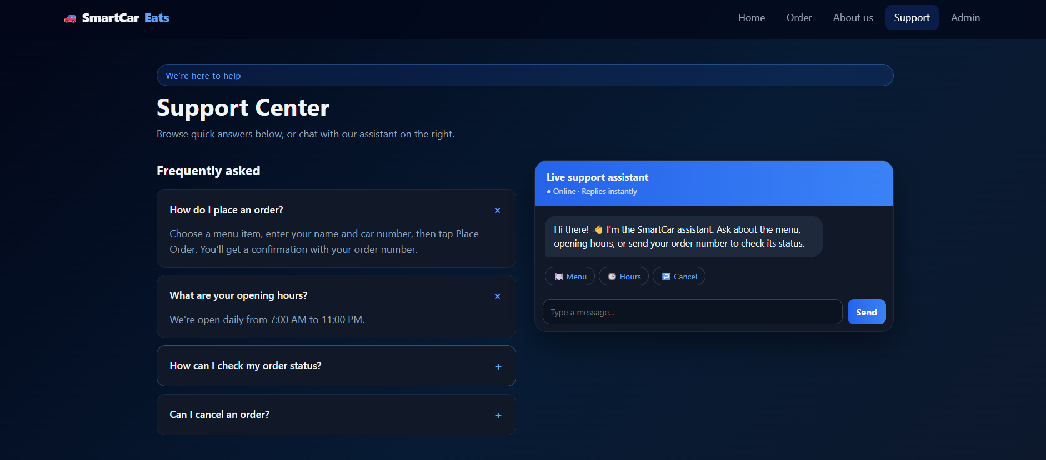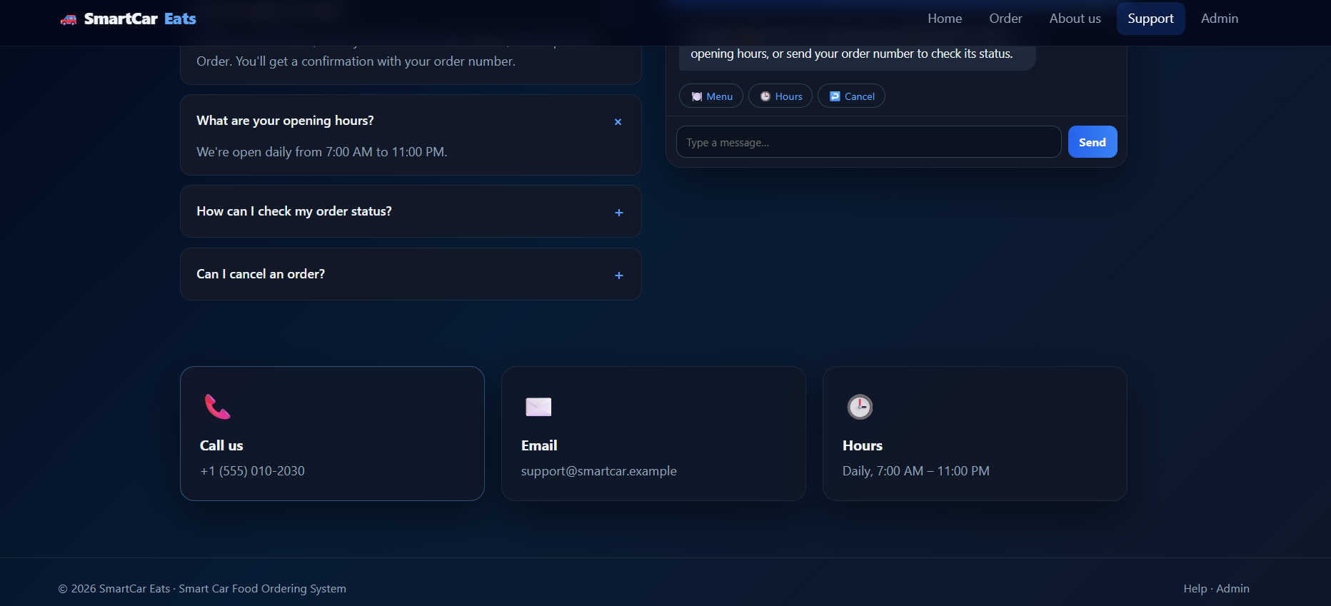

ADMIN PAGE
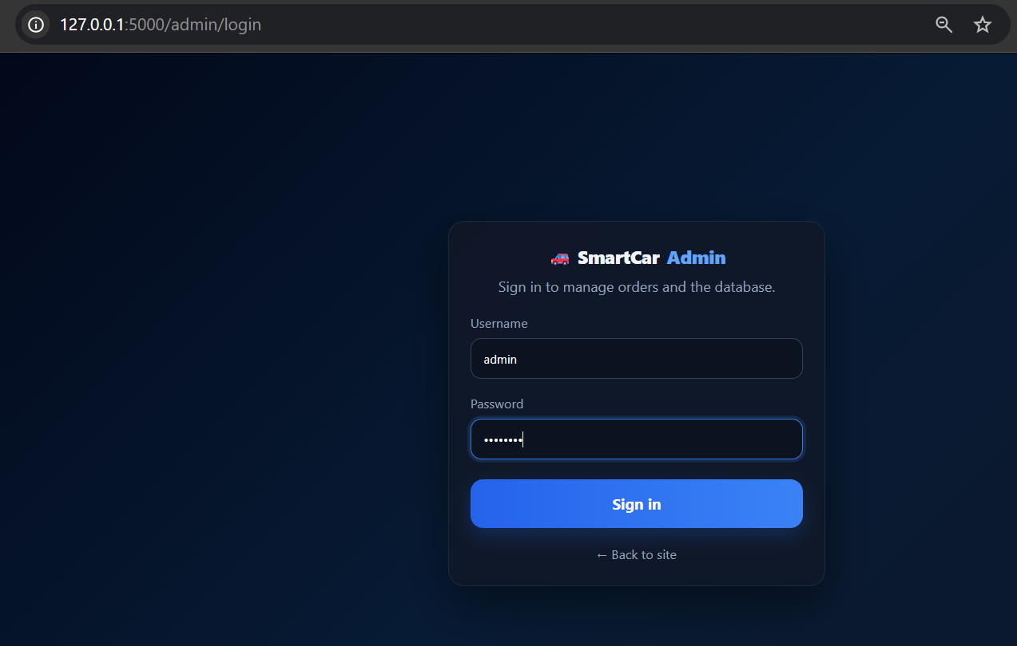
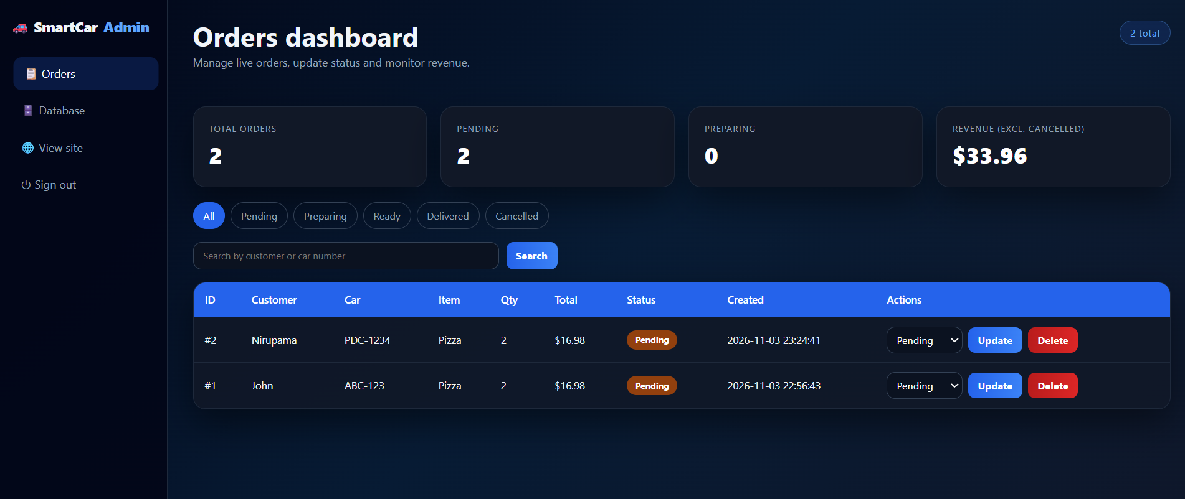
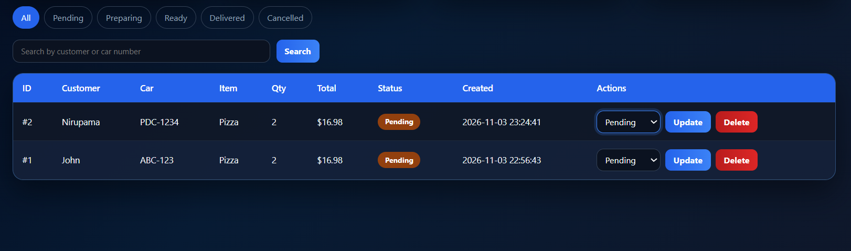
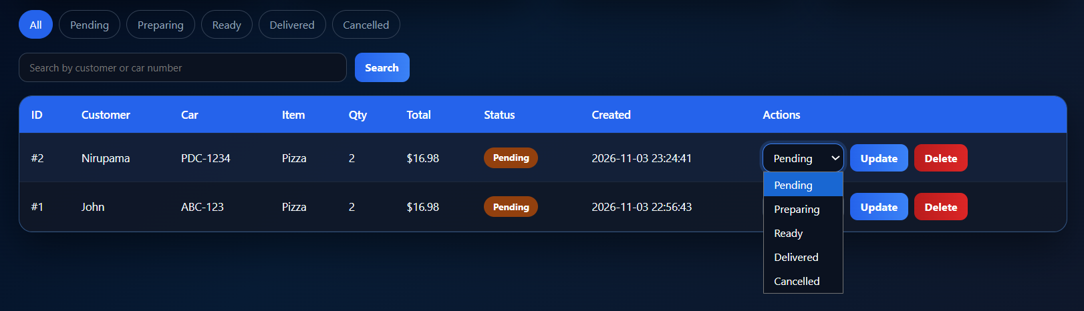
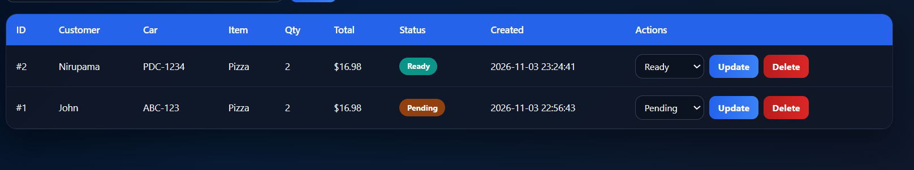
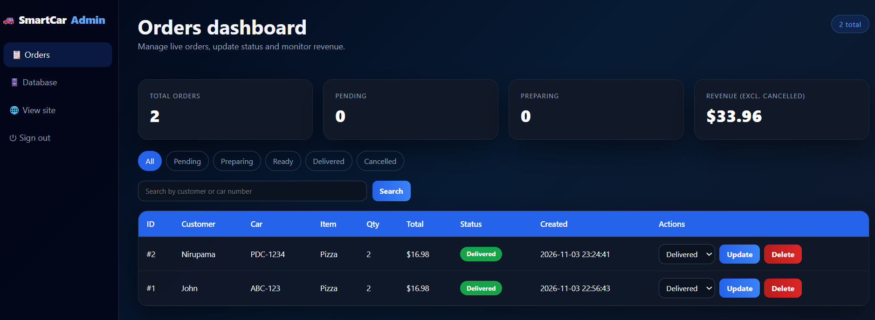
ORDER PAGE (USER), the order status got updated.
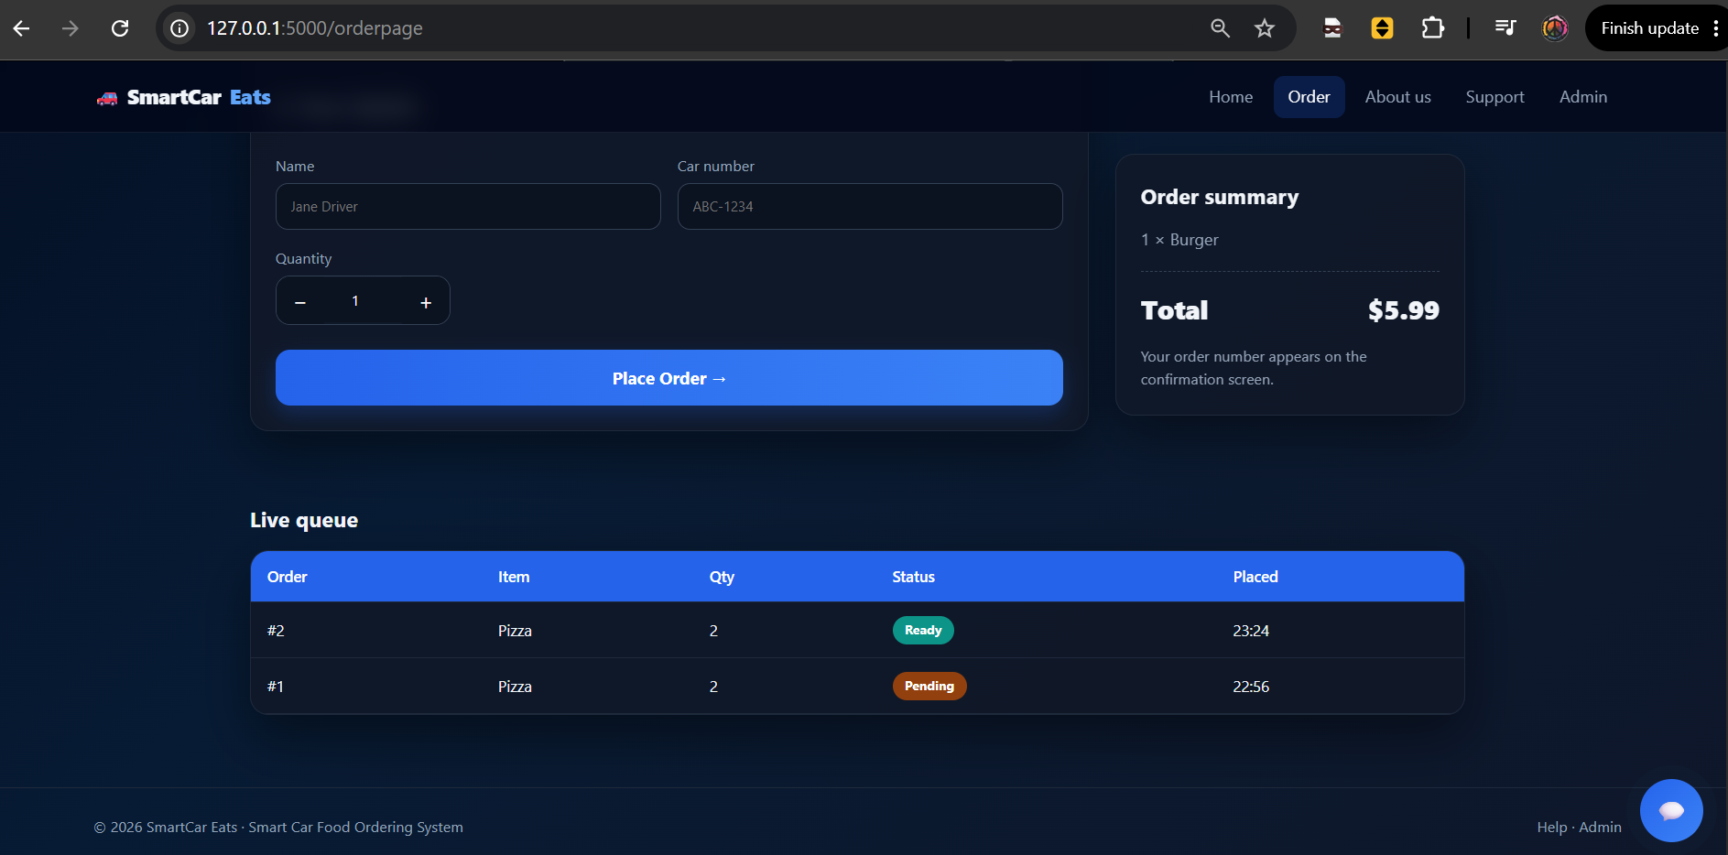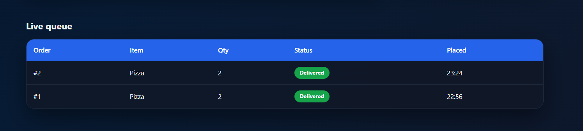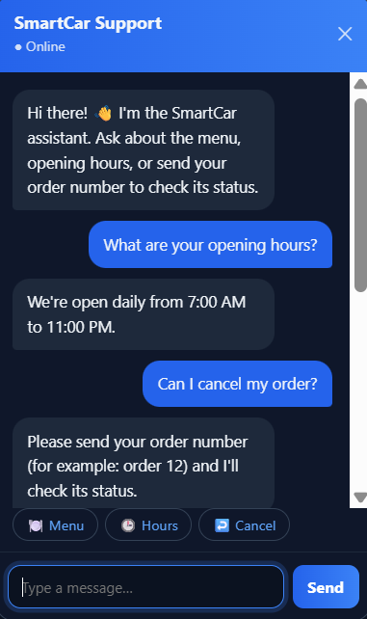
[STEP 6] UPDATE GOOGLE DOC PERMISSIONS:
TOP RIGHT > SHARE > ANYONE WITH THE LINK
[STEP 7] UPDATE YOUR NAME IN GOOGLE DOC FILE:

[STEP 8] SHARE LINK IN WHATSAPP GROUP:

